**Image GEN framework**

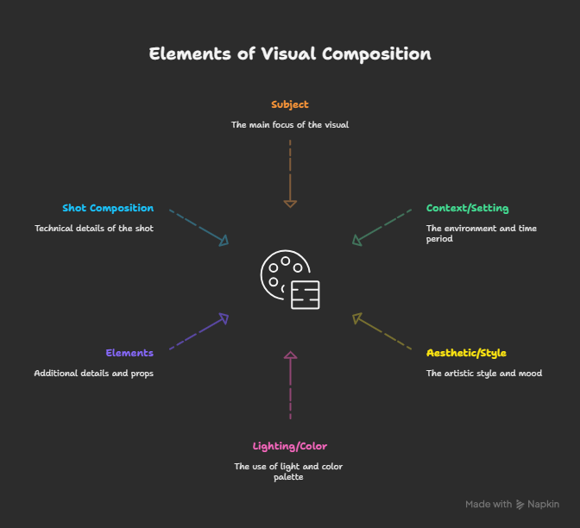

S - Subject

* What: Main focus (e.g., "A majestic Bengal tiger")
* Doing/Feeling: Actions, emotions (e.g., "stalking through a lush tropical rainforest")
* Details: Specific features (e.g., "wearing a beige trench coat")

C - Context/Setting

* Where: Location, environment (e.g., "in a sun-dappled forest clearing")
* When: Time, era (e.g., "during golden hour")
* Atmosphere: Mood, weather (e.g., "mist-filled valley")

A - Aesthetic/Style

* Artistic Style/Medium: (e.g., "photorealistic," "oil painting")
* Inspiration: Artists, movements (e.g., "in the style of Vincent van Gogh")
* Realism: (e.g., "hyper-realistic," "cartoonish")
* Mood/Tone: (e.g., "tranquil and cozy," "dramatic")

L - Lighting/Color

* Lighting: Type, direction (e.g., "dramatic side lighting")
* Color Palette: Dominant colors (e.g., "vibrant blues and pinks")
* Emphasis: Specific color focus (e.g., "accentuate metallic edges")

E - Elements (Additional Details/Props)

* Objects: Other important items (e.g., "holographic projections")
* Textures/Materials: (e.g., "glossy surface," "rough wood")
* Text (if supported): (e.g., "A poster with the text 'Summerland'")

S - Shot Composition/Technical Details

* Camera Angle/Perspective: (e.g., "close-up portrait," "wide-angle shot")
* Framing: Subject positioning (e.g., "rule of thirds composition")
* Depth of Field: (e.g., "sharp subject, blurred background")
* Resolution/Quality: (e.g., "8K resolution," "ultra-detailed")
* Camera/Lens (optional): (e.g., "shot on Canon EOS R5")

Prompt Ready Framework

S - Subject

* What :
* Doing/Feeling
* Details

C - Context/Setting

* Where
* When
* Atmosphere

A - Aesthetic/Style

* Artistic Style/Medium
* Inspiration
* Realism
* Mood/Tone

L - Lighting/Color

* Lighting
* Color Palette
* Emphasis

E - Elements (Additional Details/Props)

* Objects
* Textures/Materials
* Text (if supported)

S - Shot Composition/Technical Details

* Camera Angle/Perspective
* Framing
* Depth of Field
* Resolution/Quality
* Camera/Lens (optional)